Sears “Diversity Your Way” project.
Sears has job openings and is hiring. We hope you will encourage your clients to apply at Sears.
Why apply to Sears?
- Welcoming and open company culture
- Strong support by senior leadership and unit management for disability inclusion
- Employee tenure including people with disabilities
How to apply at Sears?
- Jobs.sears.com
- Filled out an online Application
- Fill out an Online assessment – do you need an accommodation to complete the assessment Sears has ENABLE you – Enableu@searshc.com that will provide you with support needed
- Referral Source on application– Select Tangram
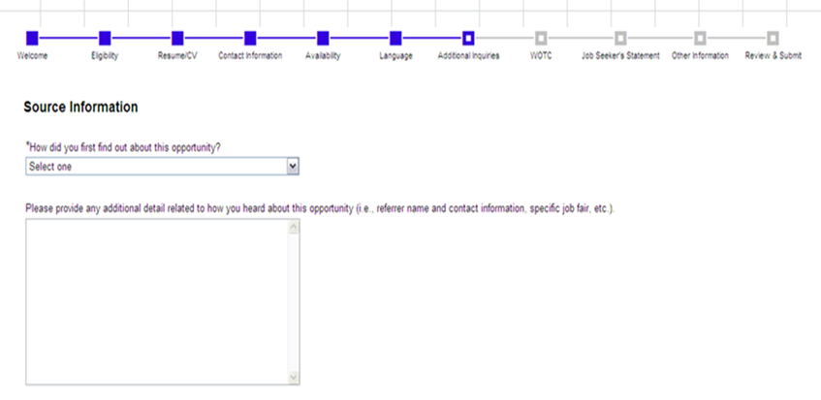
Once Tangram is selected a drop box will appear at this time you can put organization or job coaches’ name in this box
Tangram
Why Select Tangram? Tangram is a team of disability consultants that work with businesses to support them in their recruitment and hiring of people with disabilities. We are consulting with Sears and helping them aggressively hire individuals with disabilities by connecting them to local resources.
- Your clients can get in front of the hiring managers more quickly
- As consultants working with Sears we can help you and your clients with the application process and status

OR
Fill out a profile on www.workforceaccelerator.com

The first job matching database and it’s FREE. Workforce Accelerator uses a scientific approach to match people with disabilities and veterans to open job positions. Sears has all job positions listed in Workforce Accelerator. Workforce Accelerator can help identify which position best Match your experience and abilities with positions at Sears. For more information you can contact swhite@thetangramway.org

